Name: __________________________________________________________ Period: __________

**Unit 7: Surface Processes**

**Mass Movements Research Activity**

Topic: ‘Southern California Mudslides: Death Toll Rises to 15, With Dozens More Missing’

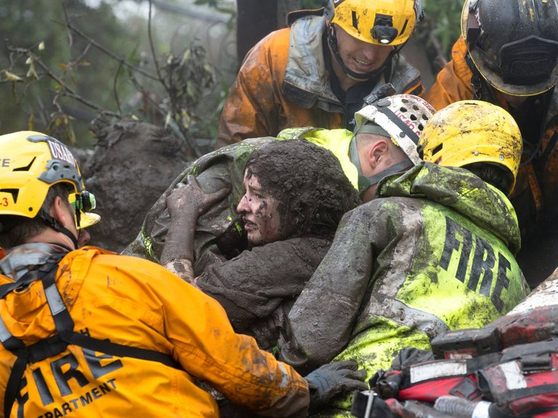

Emergency workers carrying a woman rescued in Montecito, Calif., on Tuesday.

Credit: Kenneth Song/Santa Barbara News-Press, via Reuters

**Watch the following video:**

This “How It Happens” video gives an illustrated explanation (from 2014) of the science behind mudslides. Watch it at the following link: <https://nyti.ms/2k3cCFo>

**After watching the video, answer the following questions:**

What surprised you about mudslides? ______________________________________________________________________________________________________________________________________

What did you learn from watching the video?

____________________________________________________________________________________________________________________

**Now, read the article, “**[**Southern California Mudslides: Death Toll Rises to 15, With Dozens More Missing**](https://www.nytimes.com/2018/01/10/us/montecito-mudslides-california.html)**,” and answer the following questions:**

**1.** Where are the mudslides located in California?

___________________________________________________________________

**2.** What is the size of the area affected in California?

___________________________________________________________________

**3.** What are the mudslides mixtures of?

______________________________________________________________________________________________________________________________________

**4.** What did the mudslides damage?

______________________________________________________________________________________________________________________________________

**5.** How did the wildfires that occurred last year in the same area leave the land vulnerable to mudslides?

_________________________________________________________________________________________________________________________________________________________________________________________________________

**6.** What is the extent of the damage in terms of deaths or injuries?

______________________________________________________________________________________________________________________________________

**7.** What did the mudslides do to electrical wires, gas lines, drinkable water and homes? _________________________________________________________________________________________________________________________________________________________________________________________________________

**8.** What did Jonathan W. Godt, who coordinates the landslide hazards program at the United States Geological Survey, say about the debris flow? How did it get that way? ______________________________________________________________________________________________________________________________________

**Finally, share more about what you think:**

The article addresses evacuation efforts, and says:

*Anticipating the floods, Santa Barbara County officials issued a mandatory evacuation order on Sunday evening for roughly 7,000 residents, but most chose to stay in their homes.*

*“We went door to door,” said Gina DePinto, the communications manager for Santa Barbara County. “But many refused to leave.”*

**9.** How common do you think it is for people to stay in their homes during evacuations during severe weather emergencies or natural disasters? Why? Explain your thinking. ____________________________________________________________________________________________________________________________________________________________________________________________________________________________________________________________________________

**10.** Do you think you would stay, if warned of an impending emergency or told to evacuate? Why or why not? _________________________________________________________________________________________________________________________________________________________________________________________________________

**11.** Would the type of emergency help you decide whether to stay or go? __________

What about the following scenarios – would you stay or go?

Tornado ________

Winter storm __________

Hazardous winds __________

Wildfire __________

Flood ________

Hurricane _________

Mudslide ________

Explain! Why did you answer the way you did? ____________________________________________________________________________________________________________________________________________________________________________________________________________________________________________________________________________

**A Rush to Find Survivors Amid the Mud of Southern California Enclave**

By [THOMAS FULLER](https://www.nytimes.com/by/thomas-fuller) JAN. 10, 2018

SAN FRANCISCO — Rescue workers scoured mud-swollen riverbeds in the wealthy Southern California enclave of Montecito on Wednesday, clutching to the hope that they might find some of the more than a dozen people missing after mudslides swept away about 100 houses.

At least 17 people were killed in mud flows so powerful that some one-story ranch homes in the area, which is northwest of Los Angeles, were covered up to their gutters. The devastation, sudden and violent, struck early Tuesday after a winter storm drenched and destabilized hillsides stripped bare last month by the largest wildfire in California history.

“Hundreds of people have been rescued and evacuated, many of them having to be hoisted out of the area by our aircraft,” Bill Brown, the Santa Barbara County sheriff, said Wednesday afternoon.

After surveying the affected area by aircraft, the sheriff said it was “very stunning to see the extent of the devastation, to see the breadth of the area that has impacted so terribly by this.”

Photo

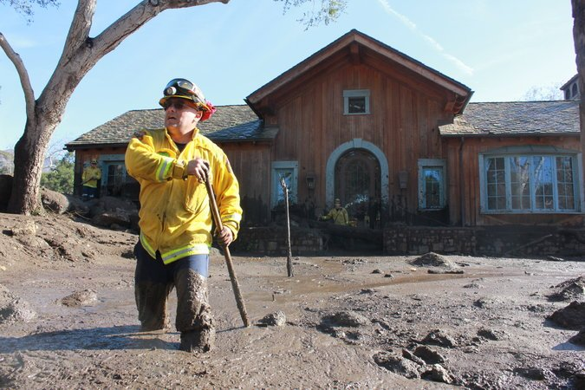

Alex Jimenez of Cal Fire searched for survivors on East Valley Road in Montecito. Credit Sky Gilbar for The New York Times

The authorities said 28 people were injured, four of them critically.

At least 300 houses were damaged in the Montecito area and many more were listed by the authorities as “threatened.”

“We are still in the hopeful, optimistic mode that we can find survivors,” said Mike Eliason, a spokesman for the Santa Barbara County Fire Department, which has rescued six people since the hillsides gave way.

Canine units worked their way along the Montecito and San Ysidro Creeks, where a large number of houses were swept away. The area near the creeks was the most treacherous, Mr. Eliason said, as creeks swelled with the sudden torrents of water mixed with ash from the fires, rocks and dirt.

“Some single-story homes were obliterated, just wiped off the foundation,” he said. “Others had holes blown through from boulders.”

The mud also hid some dangers from rescue workers.

“We’ve gotten multiple reports of rescuers falling through manholes that were covered with mud, swimming pools that were covered up with mud,” Anthony Buzzerio, a Los Angeles County fire battalion chief, told The Associated Press. “The mud is acting like a candy shell on ice cream. It’s crusty on top but soft underneath, so we’re having to be very careful.”

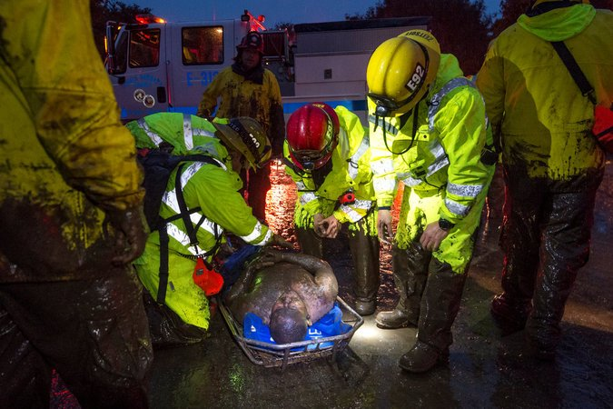

Emergency workers rescued a man after a mudslide in Montecito on Tuesday. Credit Kenneth Song/Santa Barbara News-Press, via Reuters

Five highways remained closed on Wednesday, including rural, two-lane roads, said Tim Weisberg, a spokesman for the California Department of Transportation. The main north-south roadway, the 101 Freeway, will be closed until at least Monday.

“There are some portions that look like a riverbed,” Mr. Weisberg said of the 101. “It’s a mixture of dirt, debris, boulders, rocks. In some areas it can be six inches or a foot deep.”

Ron Werft, president of Cottage Health, a hospital in Santa Barbara that has treated those injured in the mudslides, said the hospital had to shuttle personnel by boat and by air as a result of the closing of the 101, a crucial north-south artery.

Under blue skies Wednesday, rescue workers made progress, clearing roads that had trapped residents in the area around Romero Canyon, northeast of Montecito. But the longer-term consequences were also becoming evident, including damage to water mains and smaller pipes that provide the area with water.

“We have no water currently in storage,” said Nick Turner, general manager of the Montecito Water District.

A steep slope, made unstable by rain or fire, can give way without warning, creating a destructive torrent of rock and mud.

By Aaron Byrd, Leslye Davis, Henry Fountain and Catherine Spangler on Publish Date March 25, 2014. Photo by Aaron Byrd/The New York Times.

The water district instructed those residents still receiving tap water to boil it before using it for cooking or drinking.

Using bulldozers and other heavy equipment, workers cleared trees, boulders, downed power lines, household items and building material that had been swept onto the roads.

“A little bit of everything you could imagine, including a kitchen sink,” Mr. Eliason said. “Literally a kitchen sink was found.”

Among the dead was Roy Rohter, 84, said Michael Van Hecke, a friend and the headmaster of St. Augustine Academy, a classical Catholic school Mr. Rohter founded in nearby Ventura. Mr. Van Hecke said he learned of his friend’s death from Mr. Rohter’s daughter.

“He was a real scrapper, an entrepreneur,” Mr. Van Hecke said. “He bootstrapped himself all the way up to a very successful life.”

The mudslide also injured Mr. Rohter’s wife, Theresa, at their home in Montecito.

Amber Anderson, a spokeswoman for the joint recovery effort, which involves 14 helicopters and nearly 500 personnel — including firefighters and emergency workers from several counties — said the affected area was nearly 20,000 acres.

Among those who were reported missing on Tuesday were the father of a boy who was swept hundreds of yards downstream, and the father of a sailor stationed in Hawaii.

Montecito is home to mansions owned by celebrities like Oprah Winfrey and Ellen DeGeneres, but most of the damage occurred to more modest homes in the flatlands.

The wreckage of the downpour, coming so soon after the wildfires, was not a coincidence but a direct result of the charred lands, left vulnerable to quickly forming mudslides. The wildfires, known as the Thomas Fire, burned over 280,000 acres last month spanning Santa Barbara and Ventura Counties, and became California’s largest on record. The area has not received significant rain since last spring.

“I think most people are really shocked at the extent of the damage and how big the impact was to the area,” Sheriff Brown said in a television interview. “Although we knew that this was coming you couldn’t help but be amazed at the intensity of the storm.”

Jonah Engel Bromwich and Patricia Mazzei contributed reporting from New York.